Task Report

Task Description
1.Which member devices need to be updated?
2. Discover Login activity, sleuthing for unusual activity.

Because we will be searching databases with lots of data, it is best to use SQL

Machine Info
Retrieve all employee device information

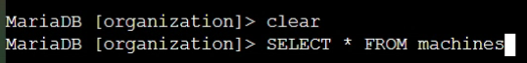

The SELECT indicator is for choosing the table columns and the FROM indicator is for choosing which table to query

Command Semantics
    - SELECT *
FROM machines; display all columns from the “machines” table
Output Excerpt -

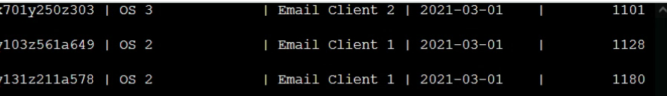

Discover Email Client
1.What email client does a specific machine use?

Command Semantics
    - SELECT device_id, email_client
FROM machines; display device_id & email_client columns from the “machines” table.
Output Excerpt -
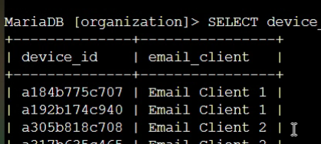

Check Patch Update on Machines
What machines need patch up-dates?

Command Semantics
    - SELECT device_id, operating_system, OS_patch_date
FROM machines; display device,_id, operating_system, OS_patch_date columns from the “machines” table
Output Excerpt -
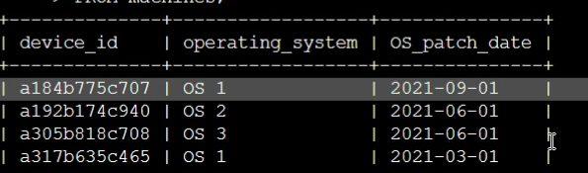

Discover Geographic Login Locations
1. Discover log in locations to ensure they are from expected locations.
NOTE: You will see from the screenshots here that SQL is not case sensitive, but has a case format for ease of use only

Command Semantics
    - SELECT country, event_id
FROM log_in_attempts
ORDERBY country; display “country” and event_id columns from the log_in_attempts table and put the results in alphabetical order based on the “country” column.
Output Excerpt -
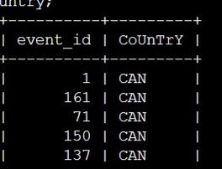

Discover Log in Attempt Times
1. Discover the times of log in attempts to ensure the attempts were made during normal business hours.

Command Semantics
    - SELECT username, login_date, login_time
FROM log_in_attemps;
Output Excerpt -
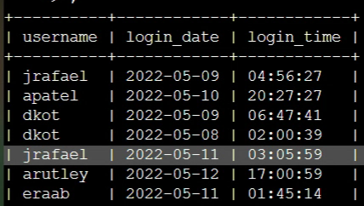

Order Data
1. Provide the same information as in the previous step, but organize it to make the information easier to read, ordering by login_date.
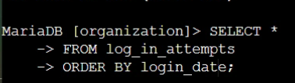

Command Semantics
    - SELECT *
FROM log_in_attempts
ORDER BY login_date; display all columns from the log_in_attempts table ordering the information by login_date
Output Excerpt -

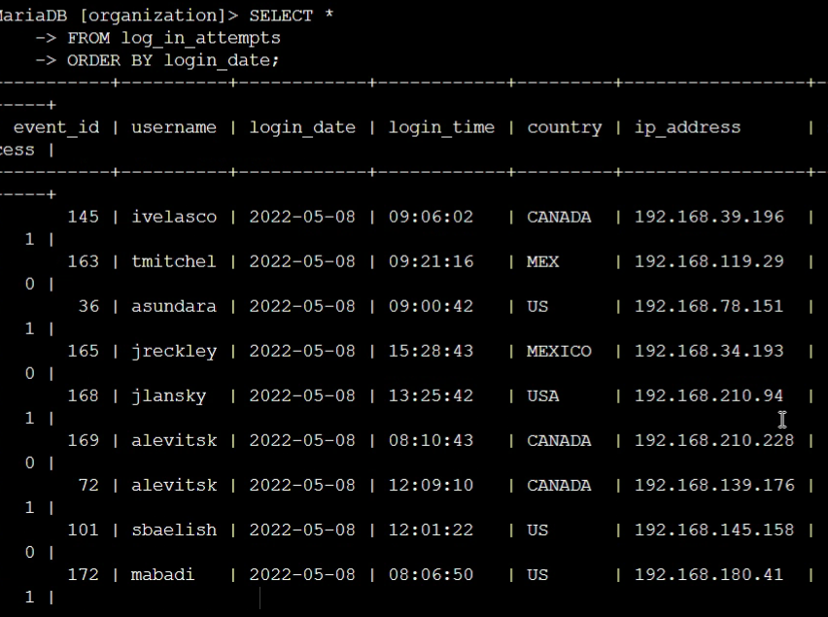

Summary
The SQL basics utilized in this scenario are part of everyday, security hardening tasks that a Cybersecurity engineer might find in their workload on any given Tuesday. After having hot-wings, of course. We used the SQL function to discover employee machine, machine email servers and login attempt information including geographic location and date & time of attempts. Lastly, we enjoyed the ORDER BY command to make searching through the data a breeze.

